**Assignment No. 2**

**Name of Programmer: Vishal Pravin Jatti Roll No. : MC23F14F026**

**Q.1 Write a program to count the total number of digits in a number**

num = int(input("Enter the number to count the total number of digits in a number:"))

temp = num

count = 0

while temp > 0:

count += 1

temp //= 10

print ("The Total Number Of Digits In a Number {0} Is {1}".format(num,count))

**Output:**



**Name of Programmer: Vishal Pravin Jatti Roll No. : MC23F14F026**

**Q.2 Write a Python function to check whether a number is perfect or not from 1 to 10000**

def isPerfect(num):

if num == 1:

return False

sum = 1

for i in range(2, num // 2 + 1):

if num % i == 0:

sum += i

if sum == num:

return True

else:

return False

for i in range(1,10000+1):

if isPerfect(i):

print(i,end=" ")

**Output:**



**Name of Programmer: Vishal Pravin Jatti Roll No. : MC23F14F026**

**Q.3 Find the first occurrence of a number in a list using a while loop:**

def find_first_occurrence(lst, num):

i = 0

while i < len(lst):

if lst[i] == num:

return i

i += 1

return -1

numbers = [1, 2, 3, 4, 5, 5, 6, 7, 8, 9]

print(numbers)

occur = int(input("Enter the number to find the Occurance "))

print(find_first_occurrence(numbers, occur))

**Output:**

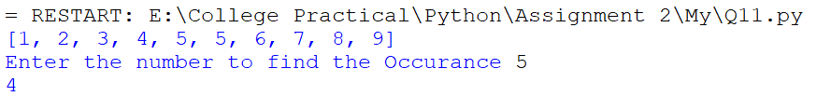

**Name of Programmer: Vishal Pravin Jatti Roll No. : MC23F14F026**

**Q.4 Write a program to find the list of words that are longer than n from a given list of words.**

def find_long_words(words, n):

long_words = []

for word in words:

if len(word) > n:

long_words.append(word)

return long_words

words = ["apple", "banana", "cherry", "date", "fig", "grape"]

n =int(input("Enter value of n : "))

print("List of Words is : ",list(filter(lambda word: len(word) > n, words)))

**Output:**



**Name of Programmer: Vishal Pravin Jatti Roll No. : MC23F14F026**

**Q.5 Write a Python program to check if a list is empty or not.**

def check_list_empty(input_list):

if len(input_list) == 0:

print("The list is empty.")

else:

print("The list is not empty.")

my_list1 = []

check_list_empty(my_list1)

my_list2 = [1, "Vishal", 3]

check_list_empty(my_list2)

**Output:**



**Name of Programmer: Vishal Pravin Jatti Roll No. : MC23F14F026**

**Q.6 Write a Python program to extract specified size of strings from a give list of string values.**

def extract_strings(input_list, min_length=0, max_length=-1):

extracted_strings = []

for string in input_list:

if min_length <= len(string) <= max_length:

extracted_strings.append(string)

return extracted_strings

List_String = ["Vishal","VJ","Ankit", "Rahul", "Aryan", "Prince"]

extracted_strings = extract_strings(List_String, 4, 5)

print(extracted_strings)

**Output:**



**Name of Programmer: Vishal Pravin Jatti Roll No. : MC23F14F026**

**Q.7 Write a Python program to check whether the given string is binary.**

def is_binary_string(string):

if not string:

print("Entered String is not Binary ")

pass

for char in string:

if char not in ('0', '1'):

print("Entered String is not Binary ")

pass

print("Entered String is Binary ")

string2 = input("Enter any String : ")

is_binary_string(string2)

**Output:**



**Name of Programmer: Vishal Pravin Jatti Roll No. : MC23F14F026**

**Q.8 Write a Python program to compute the sum of the digits in a given string.**

def sum_of_digits(s):

sum = 0

for c in s:

if c.isdigit():

sum += int(c)

return sum

str = input("Enter a String Containing digits and alphabet: ")

print("Sum of the digits are:")

print(sum_of_digits(str))

**Output:**

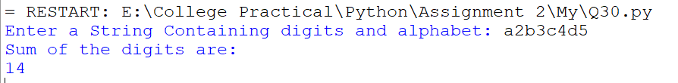

**Name of Programmer: Vishal Pravin Jatti Roll No. : MC23F14F026**

**Q.9 Write a Python program to replace the last value of tuples in a list.**

**# Sample list: [(10, 20, 40), (40, 50, 60), (70, 80, 90)]**

**# Expected Output: [(10, 20, 100), (40, 50, 100), (70, 80, 100)]**

list_of_tuples = [(10, 20, 40 ,50), (40, 50, 60), (70, 80, 90)]

lst=[]

for i in list_of_tuples:

temp=i[:len(i)-1]+(100,)

lst.append(temp)

print(lst)

**Output:**



**Name of Programmer: Vishal Pravin Jatti Roll No. : MC23F14F026**

**Q.10 Write a program that accepts a sentence and calculate the number of letters and digits. Store the result in a dictionary.**

def count_letters_and_digits(sentence):

letter_count = 0

digit_count = 0

for char in sentence:

if char.isalpha():

letter_count += 1

elif char.isdigit():

digit_count += 1

result = {"letters": letter_count, "digits": digit_count}

return result

user_sentence = input("Please enter a sentence: ")

print(count_letters_and_digits(user_sentence))

**Output:**

